FACTORS INFLUENCING SPEAKING ANXIETY AMONG FIRST-YEAR ENGLISH EDUCATION STUDENTS
Nesya Tasya Margareta^{1*}, Kurniasih², Febti Ismiatun³
^{1,2,3} Faculty of Teacher Training and Education, University of Islam Malang
Email : ¹ 22201073025@unisma.ac.id
² kurniasih@unisma.ac.id
³ febtiismi@unisma.ac.id

Abstract
This study examines factors influencing speaking anxiety among first-year English Education students during their transition from high school to university. Speaking anxiety is a common issue in English speaking classes and can affect students’ confidence and willingness to participate. Therefore, the study aims to identify the levels and aspects of speaking anxiety, its causes, and the strategies students use to cope with it. A mixed-methods design with an explanatory sequential approach was employed. Quantitative data were collected using the Foreign Language Classroom Anxiety Scale (FLCAS) to determine students’ levels and aspects of speaking anxiety. Based on the questionnaire results, four students with moderate to high anxiety levels were selected through purposive sampling for the qualitative phase. Qualitative data were gathered through photovoice and photo-elicited interviews guided by the SHOWed technique to explore students’ experiences, causes of anxiety, and coping strategies.The findings reveal that most students experienced mild speaking anxiety, with fear of negative evaluation as the most prominent aspect, followed by communication apprehension and test anxiety. Speaking anxiety was influenced by psychological, linguistic, and environmental factors. To manage their anxiety, students employed strategies such as preparation, practice, peer support, and relaxation activities. These findings highlight the importance of supportive learning environments and effective teaching strategies in reducing speaking anxiety and enhancing students’ confidence in speaking English.

Keywords: Speaking Anxiety, First-Year Students, Photovoice, Mixed-Method

INTRODUCTION
There are four fundamental skills in English language learning are listening, reading, writing, and speaking (Utama et al., 2023). The most important of the four skills is speaking to improve good communication (Alifah et al., 2021). One fundamental skill for communication is arranging structured words so they can be understood verbally or non-verbally. Speaking helps students share their feelings, ideas, and opinions, but many students struggle to speak because they have limited vocabulary, afraid of making mistakes, and lack confidence (Damayanti & Listyani, 2020).
The above mentioned challenges drive students’ anxiety, which affects how they perform when speaking in front of others or during class activities. Many of English as a Foreign Language (EFL) students find it difficult to speak English fluently, even though they have studied English for a long time. Many students still feel afraid or nervous when speaking English, especially in front of public (Nuradilla, 2023).
Anxiety is a primary factor that affects students’ ability to speak. Amini (2020) stated that students will feel anxious when their lecturer calls them to speak in front of others and they will avoid eye contact with their lecturer because they are afraid of being asked. Anxiety can reduce concentration and make students forget what they want to say (Bakhtiar & Suwandi, 2022). When students feel anxious, they may avoid speaking in class, even when they understand the topic. Students with low self-confidence often do not practice or push themselves to speak English in front of a large audience (Lingga et al., 2020). Students’ speaking performance is strongly influenced by their confidence level, which often relates to previous speaking experiences and the classroom environment.
This situation is even more challenging for first-year English Education students, who use English frequently in the classroom. During the transition to the university environment, students face not only academic challenges but also emotional ones. They have to learn to adapt to a new environment. In addition, they have to build new friendships, manage their time well, and cope with stress or pressure that may come from the new environment (Stokoe et al., 2024). Indeed, the adaptation of first-year students to the university environment and culture will result in stress and depression in psychology. Furthermore, the transition they experience will also affect their academic performance (Eusafzai, 2022). This transition period can easily cause nervousness and a lack of confidence, especially when students are required to communicate in English. These challenges often increase students’ anxiety, especially when they are expected to communicate fluently in English.
The anxiety experienced by students has many causes, especially when learning English as a foreign language. Sulistyowati (2023) mentioned that a lack of language mastery can be one of the main causes of speaking anxiety, along with low motivation and an unsupportive learning environment. For example, EFL students find it challenging to deliver sentences without understanding grammar structure and having enough vocabulary, which often causes problems in speaking accurately. Understanding and correctly applying grammatical rules is important to form clear and correct sentences, as grammatical mistakes can lead to confusion and misunderstanding. Without mastering enough vocabulary, students also struggle to express their ideas and find it difficult to follow conversations. In addition, low self-confidence and fear of making mistakes are also important factors that lead to speaking anxiety (Nuradilla, 2023). Arifin (2025) added that limited vocabulary and grammatical errors can make students’ speaking anxiety even worse. These factors strongly affect students who feel nervous when speaking English in public or in an academic forum.
According to Horwitz et al. (1986), speaking anxiety can be divided into three main aspects: communication apprehension, fear of negative evaluation, and test anxiety. Communication apprehension refers to the feeling of nervousness or fear that students experience when speaking in front of others or interacting in English. Fear of negative evaluation happens when students worry about being judged or criticized by teachers or classmates. Meanwhile, test anxiety appears when students feel stressed or afraid of making mistakes during tests, presentations, or speaking tasks. These three aspects of anxiety can strongly affect students’ confidence and performance in speaking English. These categories help explain why different students experience anxiety in different classroom situations.
The main factor that affects students’ performance is speaking anxiety. Christy et al. (2021) mentioned that students’ performance in speaking activities or tests can be influenced by anxiety. Students who feel nervous or worried may struggle to express their ideas clearly. However, Christy et al. (2021) also noted that many other factors shape students’ speaking performance besides anxiety. Other factors such as self-confidence, preparation, and language mastery also play an important role. Limami et al. (2025) explained that low self-confidence and negative self-comparison strongly affect students’ willingness to speak. Reducing anxiety is not the only key to helping students perform better in speaking. Moreover, Putra et al. (2023) found that the relationship between speaking anxiety and speaking performance was not significant. This means that students’ performance is not always negatively affected by anxiety. Some students may still perform well even when they feel nervous, showing that speaking success is not completely determined by anxiety. Therefore, while anxiety plays a role, it is not the only factor shaping students’ speaking ability.
Most previous studies on speaking anxiety mainly focused on final-year or general university students. For example, K and Alamelu (2020) investigated the causes of anxiety among final year students, such as the fear of making mistakes, lack of English mastery, low self-confidence, and an unsupportive learning environment. Another study by Limami et al. (2025) explored the reasons why students are reluctant to use English in class. Only a few studies have explored first-year English Education students, even though this stage is an important transition from high school to university, where students often face emotional and academic challenges. Many studies also used interviews and questionnaires, but only a few used participatory visual methods like Photovoice to show students’ real experiences.
For example, Anwar and Wahyuningsih (2024) used Photovoice to find out how Indonesian pre-service English teachers dealt with stress during online learning. They found that students felt stressed because of bad internet connections, too many assignments, and boredom, but they managed it by listening to music or spending time outdoors. The photos taken by the participants represented their coping strategies, such as pictures of listening to music or YouTube, playing games online, reading books, or comics. Likewise, Nurhadi et al. (2022) used Photovoice to explore EFL student-teachers’ feelings during online thesis exams. They found that students experienced a range of emotions, including struggle, self-doubt, and happiness. The photos captured in this study included images of struggling until they fell asleep and a sketch in a notebook that represented their feeling of being tired. A flower symbolized struggling, representing their feeling of joy and happiness. A picture of the outdoors represented a loss of motivation.
These studies show that Photovoice helps students creatively express their emotions and experiences. However, no study has used Photovoice to explore the psychological factors that influence speaking anxiety among first-year English Education students during their transition to university. Therefore, this study fills the gap by using a mixed-method design, starting with a questionnaire to identify students’ level of speaking anxiety, followed by using Photovoice (Wang & Burris, 1997) to explore the psychological factors influencing speaking anxiety among first-year English Education students by investigating the level, aspects, causes, and coping strategies they experience during while moving to university. Photovoice allows students to take photos that represent and reflect on their experiences. This method helps to know what students truly feel and how they overcome their struggles. This research gives voice to students’ real experiences and can help lecturers understand how to improve their learning.
This research hopes to help lecturers and educators better understand their students’ real experiences, needs, and emotional journeys during their first year of university by giving students a voice through visual storytelling. When teachers understand these struggles, they can provide better support and create a classroom that helps students feel safe, motivated, and ready to learn. Understanding these early struggles is important because how students feel in their first year can influence their confidence, performance, and motivation throughout their time at university.

METHODS
Research Design
This study adopts an explanatory sequential mixed-methods design, beginning with quantitative data collection and followed by qualitative inquiry to deepen understanding of the findings. The quantitative phase uses the Foreign Language Classroom Anxiety Scale (FLCAS) to measure first-year English Education students’ levels and aspects of speaking anxiety. Descriptive statistics are applied to identify anxiety levels, and based on the results, four students with moderate to high speaking anxiety are selected for the qualitative phase.
The qualitative phase aims to explore the psychological factors contributing to speaking anxiety and the strategies students use to manage it during their transition to university. Photovoice is used as the primary data collection method, allowing participants to express their experiences through original and metaphorical photographs, supported by reflections and interviews. This approach enables a deeper understanding of students’ lived experiences, perceptions, and coping strategies related to speaking anxiety.

Setting and Participant
The study involved 30 first-year English Education students as the population, with quantitative data collected using the FLCAS questionnaire. Based on the results, purposive sampling was applied to select four students (two females and two males) with moderate to high anxiety levels for the qualitative phase. Students with very high anxiety declined participation, which extended the research process; therefore, participants were chosen based on both anxiety level and willingness to participate.
The selected participants had diverse English learning backgrounds prior to university, including senior high school education supplemented by study at Kampung Inggris Pare, experience in boarding schools with regular English use, participation in private English courses, and learning English primarily through formal school instruction.

Instruments
The quantitative instrument used in this study was the FLCAS questionnaire, which consists of 33 items covering three aspects of anxiety, including 24 negative and 9 positive statements. Responses were measured using a five-point Likert scale from 1 (strongly disagree) to 5 (strongly agree). Reverse scoring was applied to the nine positive items to ensure that higher scores consistently reflected higher levels of anxiety.
Qualitative data were collected through interviews and photovoice to gain a deeper understanding of the psychological factors contributing to speaking anxiety and the strategies students use to manage or overcome it during their transition to university. Each participant provided six photographs: three illustrating the causes of their speaking anxiety and three representing how they cope with or overcome it.

Data Collection
Data collection was conducted in two phases: quantitative and qualitative. In the quantitative phase, an FLCAS questionnaire was distributed to 30 first-year students via a Google Form during a class meeting. The collected data were analyzed by calculating total scores to determine students’ levels and aspects of speaking anxiety.
In the qualitative phase, four students with moderate to high anxiety levels were selected. Data were gathered through three complementary steps: photovoice, reflective writing, and photo-elicited interviews. Participants took 4–6 photographs representing their difficulties in learning English at the university level and how they overcame them. Each photograph was accompanied by a short reflective writing explaining its meaning and context. The photo-elicited interviews were guided by the SHOWed technique to encourage deeper reflection on the experiences, emotions, and significance behind the images. All interviews were recorded and analyzed using thematic analysis.

Data Analysis
Data analysis was conducted in two phases: quantitative and qualitative. In the quantitative phase, data from the 33-item FLCAS questionnaire were analyzed using a five-point Likert scale, with positive items reverse-scored so that higher total scores consistently indicated higher anxiety levels. Students’ speaking anxiety levels were classified into five categories (very anxious, anxious, mildly anxious, relaxed, and very relaxed). The results were then used to select four students (two females and two males) with moderate to high anxiety levels for the qualitative phase.
In the qualitative phase, thematic analysis was applied to reflective writings and interview transcripts. This process involved identifying key words, ideas, and emotions, and grouping them into themes to describe the causes of speaking anxiety and the strategies students use to overcome it, providing insight into their experiences as first-year English learners.

RESULT AND DISCUSSION
The Levels of Speaking Anxiety
Table 1. Students’ anxiety levels
Score Range of Anxiety | Levels | Frequency of students
124 – 165 | Very anxious | 2 students (6%)
108 – 123 | Anxious | 2 students (6%)
87 – 107 | Mildly anxious | 19 students (63%)
66 – 86 | Relaxed | 5 students (16%)
33 - 65 | Very relaxed | 2 students (6%)

Table 1 presents the speaking anxiety levels of 30 first-semester English education students based on FLCAS scores. The majority of students (63%) fall into the mildly anxious category, indicating a moderate level of anxiety when speaking English. A smaller proportion feel comfortable, with 16% categorized as relaxed and 6% as very relaxed. Meanwhile, 12% of students experience higher anxiety, being classified as anxious or very anxious. Overall, the results show that most students experience a moderate level of speaking anxiety, while only a few display very high or very low anxiety levels.

The Aspects of Speaking Anxiety
Table 2. Aspects of speaking anxiety
Aspects | Frequency of students
Communication apprehension | 7 students (23%)
Test Anxiety | 7 students (23%)
Fear of negative evaluation | 13 students (43%)
Mixed anxiety | 3 students (10%)

Table 2 describes the aspects of speaking anxiety experienced by first-year students. The dominant aspect is fear of negative evaluation (43%), indicating that many students feel anxious about being judged by lecturers or peers. Communication apprehension and test anxiety show equal proportions (23%), suggesting that students experience anxiety both during English communication and evaluation situations. Mixed anxiety represents the smallest proportion (10%), indicating that few students experience multiple anxiety aspects simultaneously. Overall, the findings show that speaking anxiety is influenced not only by language ability but also by psychological factors and the classroom environment, with fear of negative evaluation being the main source of anxiety.

The Factors Influencing Speaking Anxiety
Psychological factors
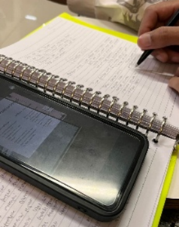  (a) | 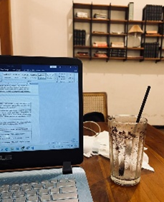  (b) | 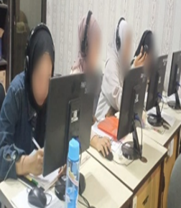  (c)
Figure 1. Student working a speaking assignment (a), student feel blank minded (b), and student working on a computer (c)
The findings from the participants’ photos and interviews illustrate common experiences of speaking anxiety among first-year students. Participant P2 described anxiety related to fear of making grammatical and vocabulary mistakes, which leads to overthinking and reduced confidence before and during speaking activities. Participant P3 expressed a lack of confidence and fear of making mistakes in front of classmates and lecturers, with speaking anxiety affecting memory and the ability to recall vocabulary. Meanwhile, participant P4 highlighted anxiety triggered by speaking in front of the class, where being the center of attention causes her mind to go blank and prevents her from speaking. Overall, these findings show that speaking anxiety is closely related to fear of making mistakes, lack of confidence, and classroom speaking situations that place students under pressure.

Linguistic Factors
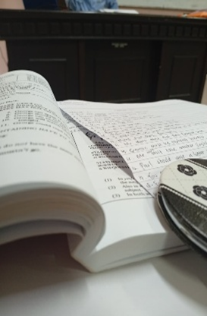  (a) | 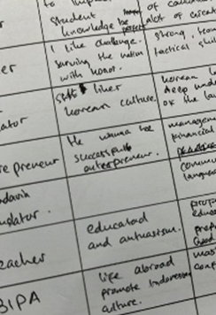  (b)
Figure 2. Student learn grammar (a) and Students write an idea (b)
This theme highlights linguistic difficulties as a source of speaking anxiety in English. Participants reported challenges in organizing ideas, using correct grammar, and forming sentences, which negatively affect their speaking performance. P1 illustrated her anxiety through photos of books and handwritten notes used as preparation to avoid mistakes, supported by her statement about fear of errors in pronunciation and grammar. Similarly, P2 showed that written notes help increase a sense of security, as anxiety often prevents her from expressing ideas clearly. Overall, the findings indicate that linguistic factors play an important role in triggering students’ speaking anxiety.

Environmental Factors
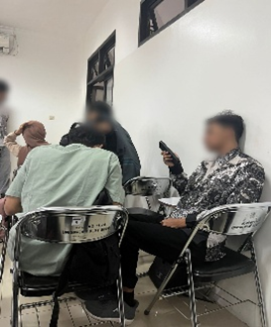  (a) |   (b) | 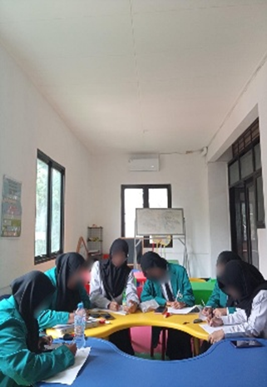  (c)

The third theme focuses on environmental factors, particularly peer support, in reducing speaking anxiety. Participants reported that support from friends helped them cope with anxiety during speaking activities. P3’s photo of a group discussion illustrates nervousness while waiting to speak, yet he felt supported when friends listened attentively. Similarly, P4’s photos show that encouragement from friends creates a sense of safety and confidence when speaking in class. P1 also highlighted that group discussions and preparation with friends help reduce anxiety and create a more relaxed atmosphere. Overall, these findings indicate that peer support plays an important role in helping students manage speaking anxiety.

The Anxiety-Reducing Strategies
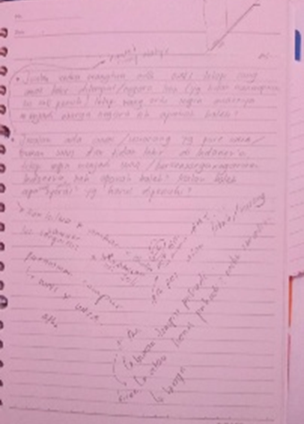  (a) | 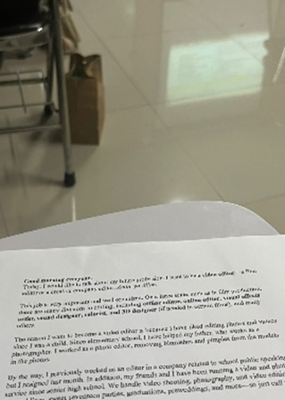  (b) |   (c) | 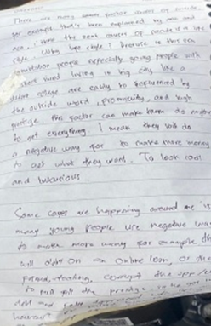  (d)
Figure 3. student draw and write (a), student prepare a script (b), script outline from chatGPT (c), and student practicing material before presentation (d)
The photos illustrate various strategies used by participants to overcome speaking anxiety during the transition from high school to university. P4 copes with anxiety through drawing and talking with friends, which helps organize thoughts and build confidence before speaking. P3 reduces anxiety by preparing and practicing a presentation script repeatedly, allowing him to feel more confident during speaking activities. Similarly, P2 uses presentation scripts as a form of self-support to feel calmer and more prepared. P1 also manages anxiety through thorough preparation by reading and practicing the text multiple times. Overall, these findings show that preparation, practice, and personal coping strategies play an important role in reducing speaking anxiety.

Discussions
The quantitative findings indicate that most first-year students in the English education program experienced speaking anxiety at a mild level, with 63% categorized as mildly anxious. This shows that feelings of nervousness when speaking English are common but do not reach an extreme level or prevent students from participating in classroom speaking activities. Mild anxiety can be understood as a normal reaction during the transition from senior high school to university, a period often associated with psychological pressure and adaptation to a new academic environment (Venezia & Jaeger, 2013). At this stage, students are still adjusting to increased exposure to English, particularly in speaking, and mild anxiety reflects an adaptation process rather than a serious psychological barrier.
Although more students were categorized as relaxed than very anxious, speaking anxiety remains an important concern in foreign language learning. Nervousness when speaking a foreign language is generally considered a normal experience (Indriyani et al., 2025) and, at a mild level, can motivate students to prepare more carefully and stay focused during speaking activities. A supportive classroom atmosphere, such as enjoyable learning activities and group discussions, can help reduce anxiety (Nety et al., 2020). However, anxiety still requires attention, as it is one of the main emotional factors influencing foreign language learning and should be addressed through appropriate instructional strategies provided by lecturers (Zulfikar, 2022).
The findings of this study differ from those of Hayati and Kaniadewi (2022), who reported higher levels of speaking anxiety among students. The dominance of mild anxiety in the present study may be explained by students’ prior exposure to English since school, which helped them develop sufficient language ability. As a result, anxiety was present but did not escalate to higher levels, supporting Young’s (1991) explanation that higher anxiety is often associated with limited language proficiency.
In terms of the aspects of speaking anxiety, fear of negative evaluation emerged as the most dominant, experienced by 43% of the students. This indicates that students’ anxiety is strongly influenced by how they perceive judgments from lecturers and peers, highlighting the role of external classroom factors alongside internal psychological aspects. This finding supports Horwitz et al. (1986), who identified fear of negative evaluation as a central component of foreign language anxiety. For first-year students, this fear may be intensified by the need to adjust to a new academic and social environment, causing them to speak cautiously or avoid speaking to prevent making mistakes (Idriyani et al., 2025). To reduce this type of anxiety, teachers are encouraged to apply strategies such as delayed corrective feedback, positive reinforcement, and collaborative activities (Tariq & Shah, 2024; Khoudri, 2024; Wijaya, 2023).
Communication apprehension and test anxiety were found in equal proportions, each affecting 23% of the students. This shows that anxiety occurs not only during formal speaking assessments but also during everyday classroom communication. Communication apprehension appears when students feel insecure and worry about understanding or expressing ideas in English, while test anxiety arises from stress related to evaluations, even when students have prepared (Indriyani et al., 2025). In contrast, only a small number of students experienced mixed anxiety, suggesting that speaking anxiety is generally driven by one dominant aspect rather than multiple factors simultaneously.
Speaking anxiety was also closely related to other language skills. Anxiety in receptive skills, particularly listening, can influence anxiety in productive skills such as speaking and writing. Difficulties in understanding spoken input may increase anxiety when students are required to produce language, showing that language anxiety should be viewed as an interconnected experience rather than as separate problems in individual language skills (Dolu et al., 2025).
Qualitative findings further reveal that speaking anxiety among first-year students is influenced by psychological, linguistic, and environmental factors, with psychological factors being the most dominant. Common psychological difficulties included fear of making mistakes, overthinking, low self-confidence, and mental blocks, especially during unprepared speaking tasks or presentations in front of the class (Hayati & Kaniadewi, 2022). These findings align with Krashen’s affective filter hypothesis, which explains that high anxiety can hinder language performance by blocking vocabulary recall and idea organization, even when students have adequate language knowledge.
In addition to psychological factors, linguistic difficulties also contributed to students’ speaking anxiety. Limited vocabulary, pronunciation problems, and difficulty in constructing sentences reduced students’ confidence when speaking English. To cope with these challenges, many students relied on scripts or notes to organize their ideas and reduce anxiety. Previous studies support this finding, showing that limited language mastery increases fear of making mistakes and speaking anxiety (Sulistyowati, 2023; Arifin et al., 2025), which in turn lowers students’ willingness to participate in speaking activities.
Environmental factors, particularly peer support and classroom atmosphere, also played an important role in influencing speaking anxiety. A positive and supportive learning environment helped students feel more relaxed and confident, while practicing with peers and receiving encouragement reduced nervousness (Limami et al., 2025). Peer support is especially important for first-year students who are still adjusting to a new academic and social setting, as emotional and social support helps them manage academic pressure (Stokoe et al., 2024).
To cope with speaking anxiety during the transition to university, students commonly employed a combination of strategies, including preparation, peer support, and relaxation techniques. Preparation, such as writing scripts and practicing repeatedly, helped students feel more confident and reduced fear of forgetting what to say (Kondo, 2004). Peer support also played a key role, as practicing with friends and receiving positive feedback helped students feel calmer and more comfortable when speaking (Young, 1992). In addition, relaxation strategies such as drawing, writing notes, or engaging in calming activities helped students control nervousness and emotional tension before speaking (He, 2017).
Overall, the findings indicate that students do not rely on a single strategy to manage speaking anxiety but instead use a combination of approaches. This pattern reflects the dominant role of fear of negative evaluation, as students attempt to control anxiety related to making mistakes and being judged by others. Although these strategies do not completely eliminate speaking anxiety, they help students manage it more effectively and remain engaged in speaking activities (Limami et al., 2025).

CONCLUSION
Bsed on research, this study explored psychological factors related to speaking anxiety among first-year English education students during their transition to university. The results show that most students experienced mild speaking anxiety, indicating that nervousness when speaking English is common but generally not severe. Fear of negative evaluation was the dominant aspect of anxiety, followed by communication apprehension and test anxiety, which occurred in both formal assessments and daily classroom interactions. Speaking anxiety was influenced by internal factors, such as low self-confidence and fear of making mistakes, as well as external factors, including classroom environment, lecturer feedback, and peer reactions. To manage their anxiety, students used strategies such as preparation, peer support, positive thinking, and accepting mistakes, which helped them gradually reduce anxiety and increase confidence in speaking English.
Teachers are encouraged to create a supportive and low-pressure classroom atmosphere by providing positive and constructive feedback, offering encouragement, and implementing group-based speaking activities to reduce students’ fear of negative evaluation. Students are advised to practice English regularly, prepare carefully before speaking activities, and maintain a positive mindset, as well as support peers and practice together to help reduce anxiety. For future research, it is recommended to involve larger samples, explore different educational contexts, and apply other qualitative methods to gain a deeper understanding of speaking anxiety in EFL settings.

REFERENCE
Alifah, F., Ashari, A., & Ni'mah, D. (2021). The correlation between the students' self-confidence and their speaking ability at English Department of University of Islam Malang. Jurnal Penelitian, Pendidikan, dan Pembelajaran, 16(18).
Amini, A., . E., & . K. (2019). A correlation between students’ anxiety levels and oral presentation performance in EFL speaking class. Journal of English Education and Teaching, 3(3), 403–412. https://doi.org/10.33369/jeet.3.3.403-412
Arifin, A. A. A., Malihah, N., & Nabella, A. C. R. (2025). Factors of EFL students’ language anxiety in English learning. Jurnal Teknologi Pendidikan : Jurnal Penelitian Dan Pengembangan Pembelajaran, 10(2), 304. https://doi.org/10.33394/jtp.v10i2.14480
Bakhtiar, M. R., & Suwandi, S. (2022). The psychological factors impacts on the students’ speaking skill. English Education Journal, 12(3), 356–363. https://doi.org/10.15294/eej.v12i3.58338
Christy, A., Jufri, & Mukhaiyar. (2021). The effect of speaking anxiety on students performance in speech class: Ninth International Conference on Language and Arts (ICLA 2020), (pp. 241-245). https://doi.org/10.2991/assehr.k.210325.043
Damayanti, M. E., & Listyani, L. (2020). An analysis of students’ speaking anxiety in academic speaking class. ELTR Journal, 4(2), 152–170. https://doi.org/10.37147/eltr.v4i2.70
Dolu, S. A. K., Kurniasih, K., & Umamah, A. (2025). The intercorrelation of anxiety among language skills. Jurnal Penelitian, Pendidikan, dan Pembelajaran, 20(21).
Eusafzai, H. A. K. (2022). Students’ transitions through English Medium Instruction environment: A Kyrgyz case. Frontiers in Education, (vol. 7, p. 858513). https://doi.org/10.3389/feduc.2022.858513
Hayati, S. N., & Kaniadewi, N. (2022). Analyzing types and levels of students’ English Speaking anxiety. ELLTER-J, 3(1), 25-35.
He, D. (2017). How to cope with foreign language speaking anxiety effectively? The case of university students in China. Electronic Journal of Foreign Language Teaching, 14(2).
Horwitz, E. K., Horwitz, M. B., & Cope, J. (1986). Foreign language classroom anxiety. The Modern Language Journal, 70(2), 125–132. https://doi.org/10.1111/j.1540-4781.1986.tb05256.x
Indriyani, J., Norawati, R., & Handayani, R. (2025). Factors causing students’ speaking anxiety in EFL classrooms at English education study program of Jambi University. Jurnal Intelek Dan Cendikiawan Nusantara, 2(5), 8469-8480.
K, R., & Alamelu, C. (2020). A study of factors affecting and causing speaking anxiety. Procedia Computer Science, 172, 1053–1058. https://doi.org/10.1016/j.procs.2020.05.154
Khoudri, I. (2024). Teachers’ strategies to alleviate speaking anxiety and foster willingness to communicate among efl high school students. International Journal of Contemporary Educational Research, 11(2), 236-249. https://doi.org/10.52380/ijcer.2024.11.2.608
Kondo, D. S. (2004). Strategies for coping with language anxiety: The case of students of English in Japan. ELT Journal, 58(3), 258–265. https://doi.org/10.1093/elt/58.3.258
Limami, L. G., Ismiatun, F., & Nasihah, D. (2025). Why don’t they speak English? a phenomenon of university students in FL context. Jurnal Penelitian, Pendidikan, dan Pembelajaran, 20(21).
Lingga, L. M., Simanjuntak, R. M., & Sembiring, Y. (2020). Students’ strategies in learning speaking skills at SMP Nasrani 3 Medan. Journal of Languages and Language Teaching, 8(1), 91. https://doi.org/10.33394/jollt.v8i1.2238
Nety, N., & Nurhaeni, N. (2020). Students’self confidence in speaking english. English Education Journal, 8-16.
Nuradilla, T. (2023). The analysis of factors causing students' speaking anxiety on speaking performance (a mixed method study at the final semester students of English Education Students State Islamic University of Syarif Hidayatullah Jakarta) (Bachelor's thesis, Jakarta: FITK UIN Syarif Hidayatullah jakarta).
Nurhadi, K., Istiqomah, L., & Gunawan, F. (2022). Adopting photovoice to explore EFL student teachers online thesis examination experiences: Lessons learned from Indonesia. Mextesol Journal, 46(3), n3.
Putra, A. T., Hasanah, A., & Desvitasari, D. (2023). Correlation between speaking anxiety and speaking achievement of the eighth grade students. Didascein : Journal of English Education, 4(1), 10–17. https://doi.org/10.52333/djoee.v4i1.71
Stokoe, M., Nordstokke, D., & Wilcox, G. (2024). First year students’ perceptions of the transition to university: The role of informational, instrumental, and emotional support. International Journal of Research in Education and Science, 10(2), 377–393. https://doi.org/10.46328/ijres.3392
Sulistyowati, T. (2023). Factors causing English Speaking Anxiety (ESA) in EFL context: A case study among post-graduate students in Indonesia. Applied Research on English Education (AREE), 1(1), 37. https://doi.org/10.26714/aree.1.1.2023.37-47
Tariq, Z., & Shah, M. I. (2024). Delayed vs immediate corrective feedback: An anxiety measure among ESL secondary level learners in Punjab. Research Journal of Social Sciences and Economics Review, 5(2), 112-120. https://doi.org/10.36902/rjsser-vol5-iss2-2024
Utama, S. B. (2023). Exploring the correlation between self-confidence and the EFL speaking achievement. Jurnal Penelitian, Pendidikan, dan Pembelajaran, 18(25).
Venezia, A., & Jaeger, L. (2013). Transitions from high school to college. The future of children, 23(1), 117–136. https://doi.org/10.1353/foc.2013.0004
Wang, C., & Burris, M. A. (1997). Photovoice: Concept, methodology, and use for participatory needs assessment. Health Education & Behavior, 24(3), 369–387. https://doi.org/10.1177/109019819702400309
Wijaya, K. F. (2023). Strategies to overcome foreign language speaking anxiety in Indonesian EFL learning contexts. LLT Journal: A Journal on Language and Language Teaching, 26(1), 214-227. https://doi.org/10.24071/llt.v26i1.4450
Young, D. J. (1992). Language anxiety from the foreign language specialist’s perspective: Interviews with Krashen, Omaggio Hadley, Terrell, and Rardin. Foreign Language Annals, 25(2), 157–172. https://doi.org/10.1111/j.1944-9720.1992.tb00524.x
Zulfikar, Z. (2022). Investigating high-school EFL learners’ foreign language anxiety: A case study at SMA 4 Banda Aceh. English Education: Jurnal Tadris Bahasa Inggris, 15(1), 96-118. https://doi.org/10.24042/ee-jtbi.v15i1.12046

